|  |  |
| --- | --- |
|  | Program Doktor Program Studi Teknik Geomatika  Departemen Teknik Geodesi  Program Pascasarjana Fakultas Teknik Universitas Gadjah Mada |

**Form Penilaian Naskah Akhir**

|  |  |  |
| --- | --- | --- |
| **Nama** | : | {Nama} |
| **NIM** | : | {NIM} |
| **Judul Disertasi** | : | {JudulDisertasi} |
| **Pelaksanaan Ujian** | : | {Tanggal} |
| **Hasil Ujian** | : | **{HasilUjian}** |

|  |  |  |
| --- | --- | --- |
| **No** | **Kriteria Penilaian** | **Nilai** |
| 1 | Naskah Disertasi (Bobot 10%) (CPMK 2/CPL c, d; CPMK 3/CPL e) | {Skor1} |

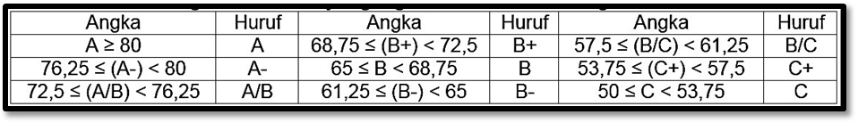

|  |  |
| --- | --- |
|  | Penguji, |
|  |  |
|  | {NamaDosen} |